**Connected to CIG LAN**

**Firefox**

Cleared cache by holding ctrl-shift-del then clicking Clear Now;

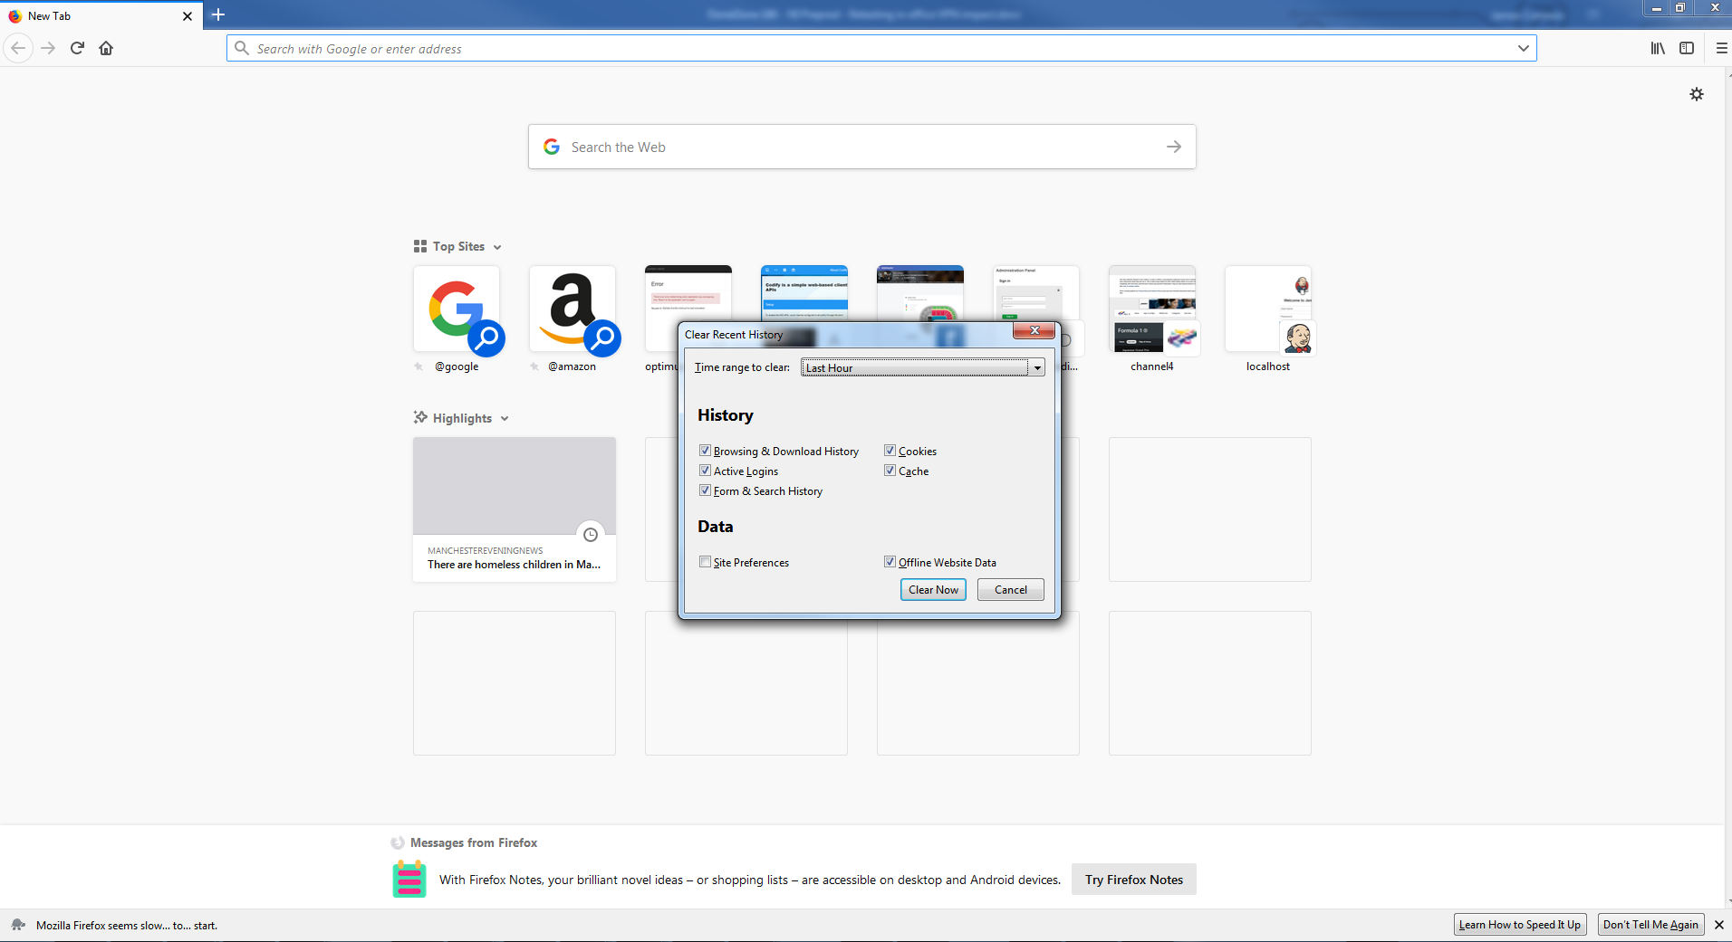

Navigated to <https://optimus.qa.callcreditdisputes.com/numerointeractive>

Logged in fine, able to view dispute fine;

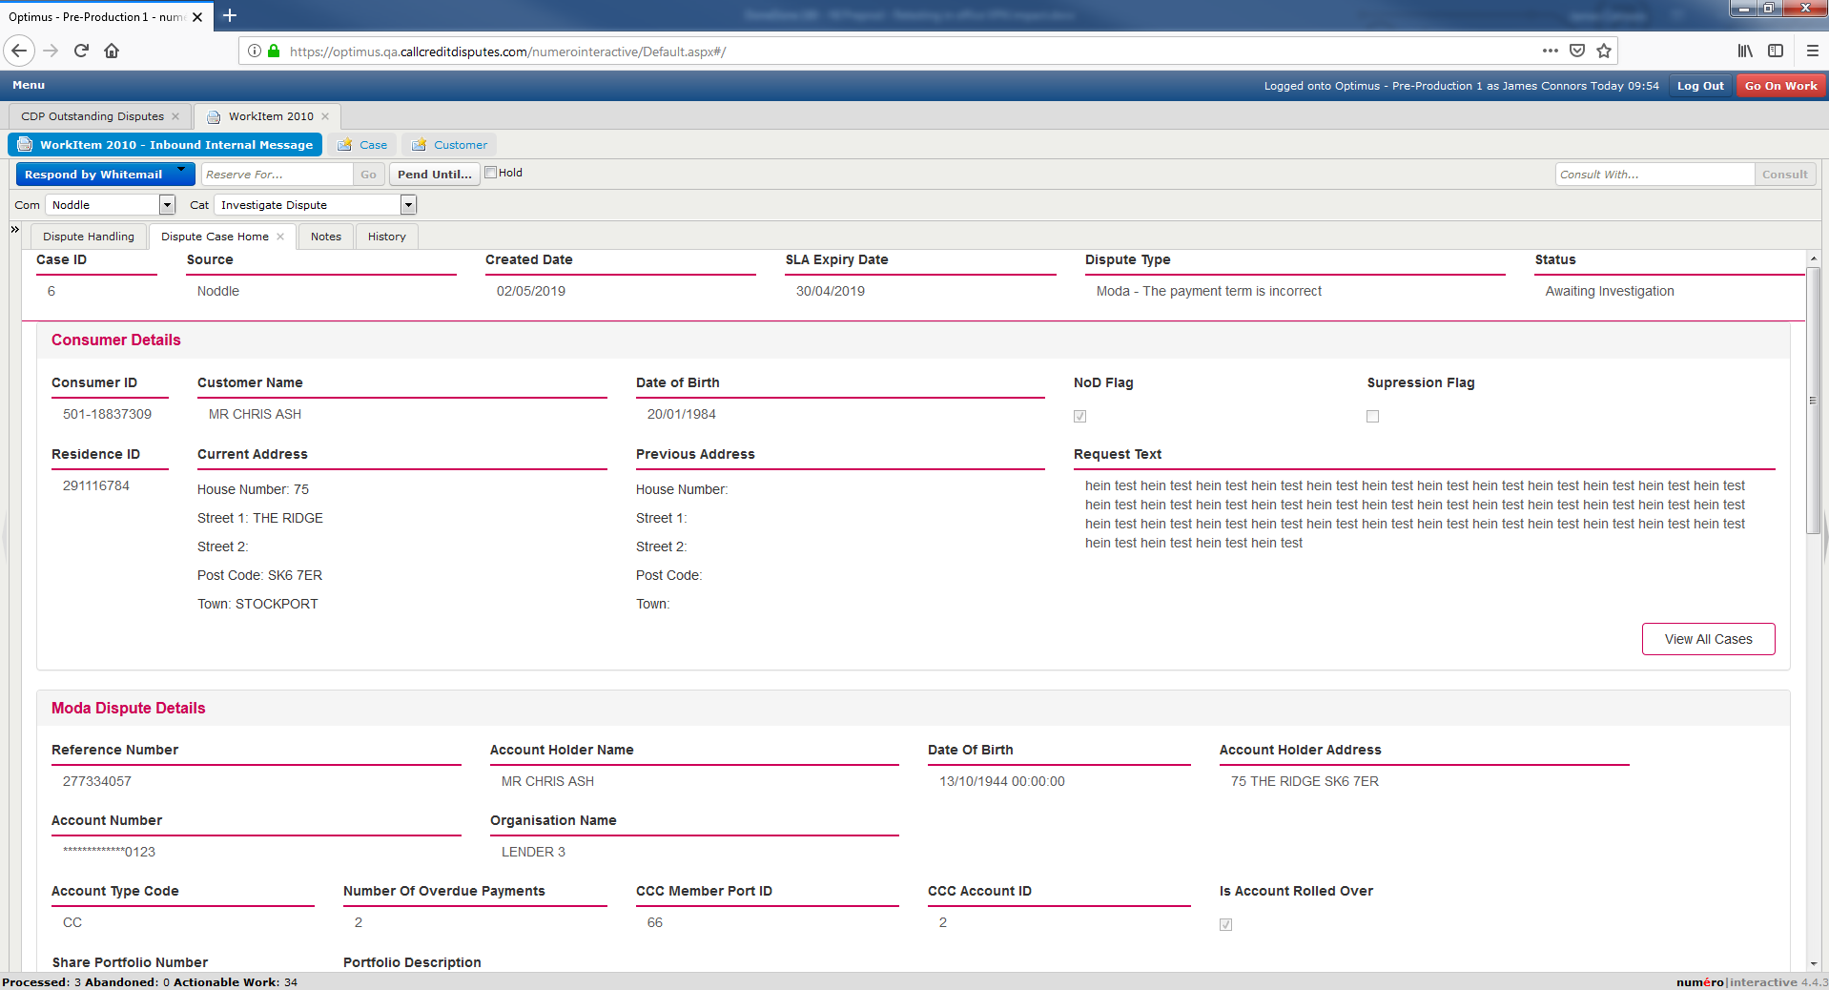

**CHROME**

Cleared history using Ctrl-Shift-Del and clicking clear data;

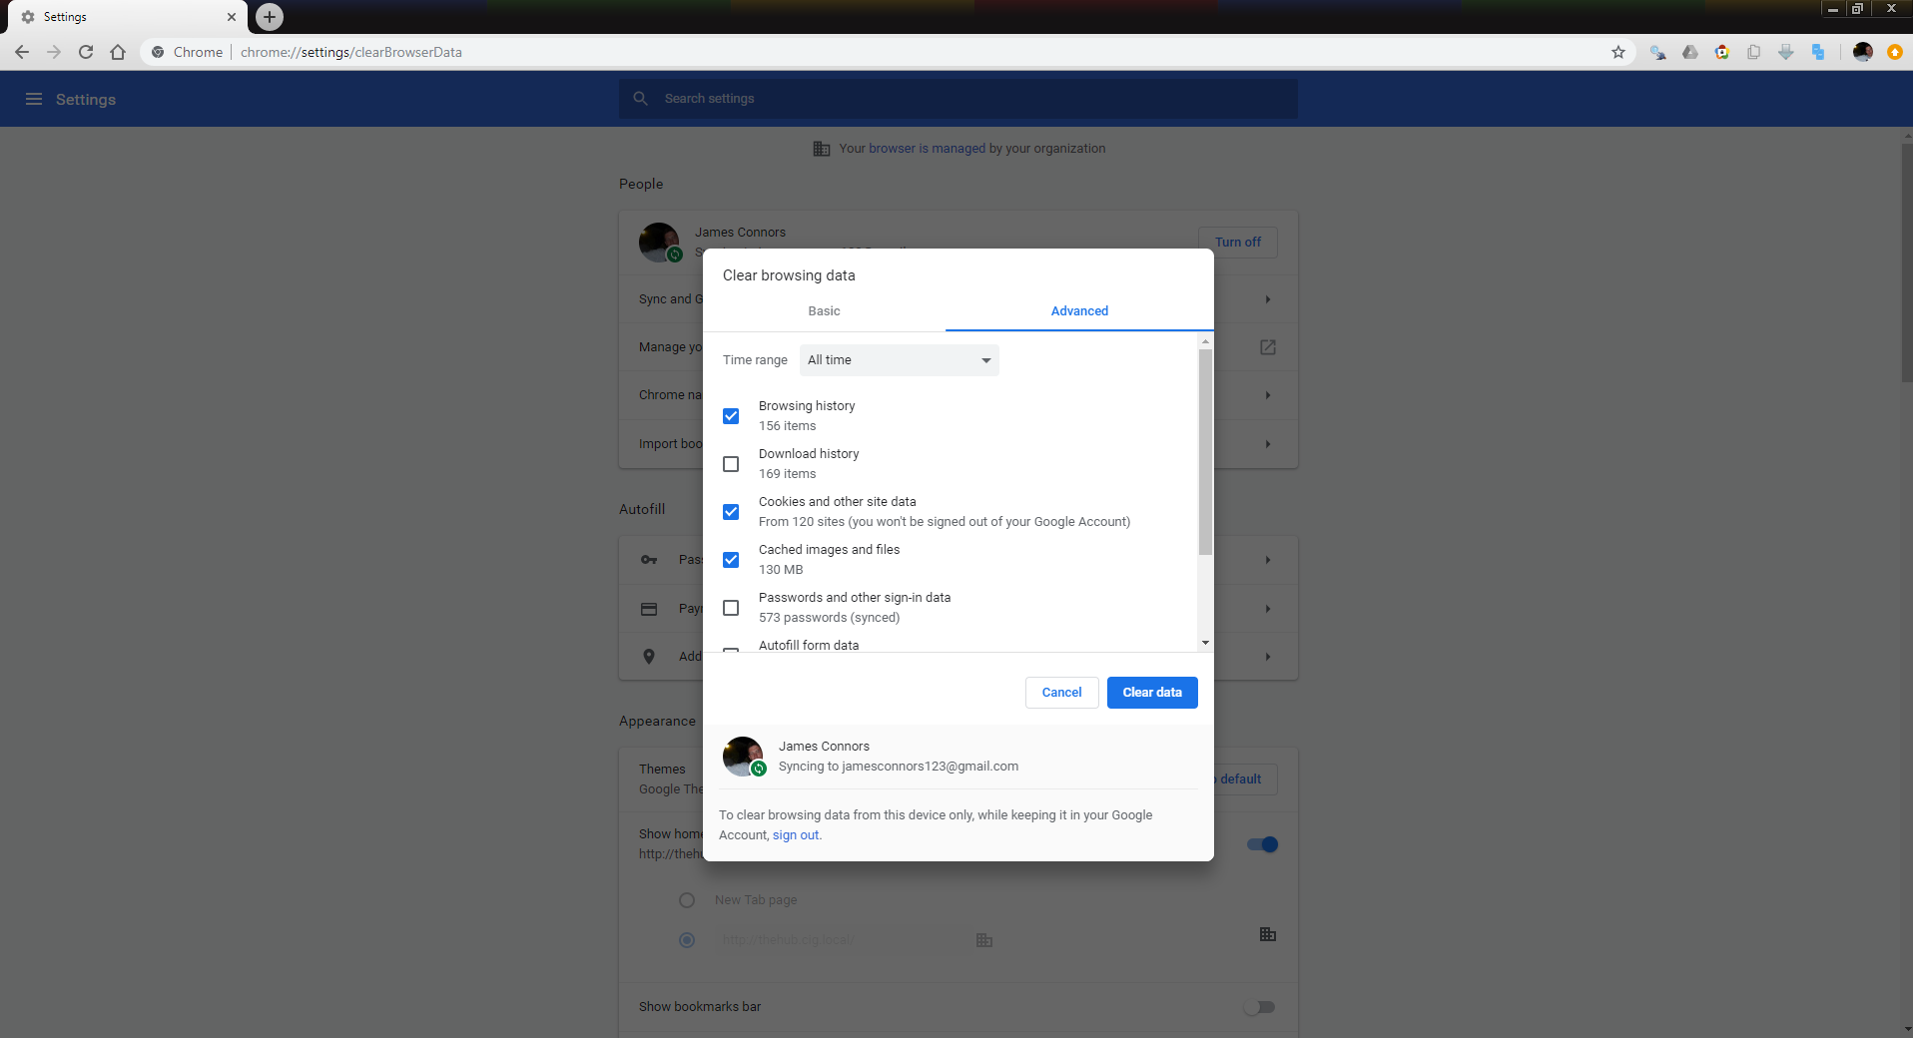

Note that it indicated that it was working with blue spinning circle but seemed to hang and not close the window or present OK button

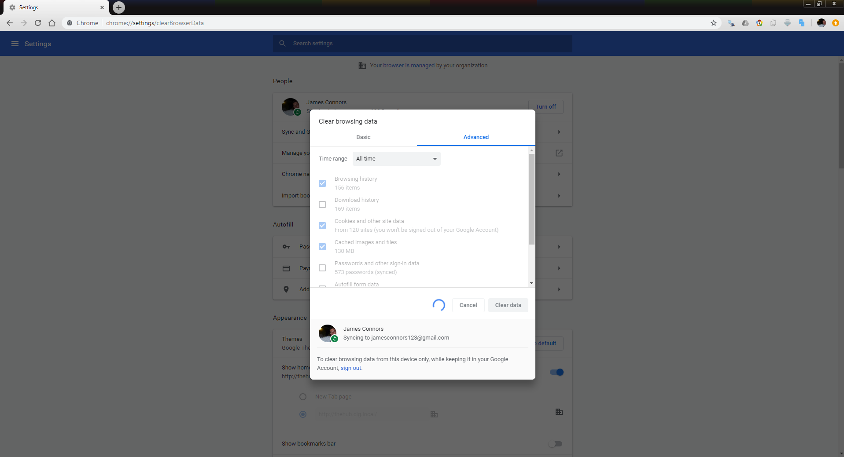

Navigated to <https://optimus.qa.callcreditdisputes.com/numerointeractive>

Optimus loaded fine and I was able to view dispute;

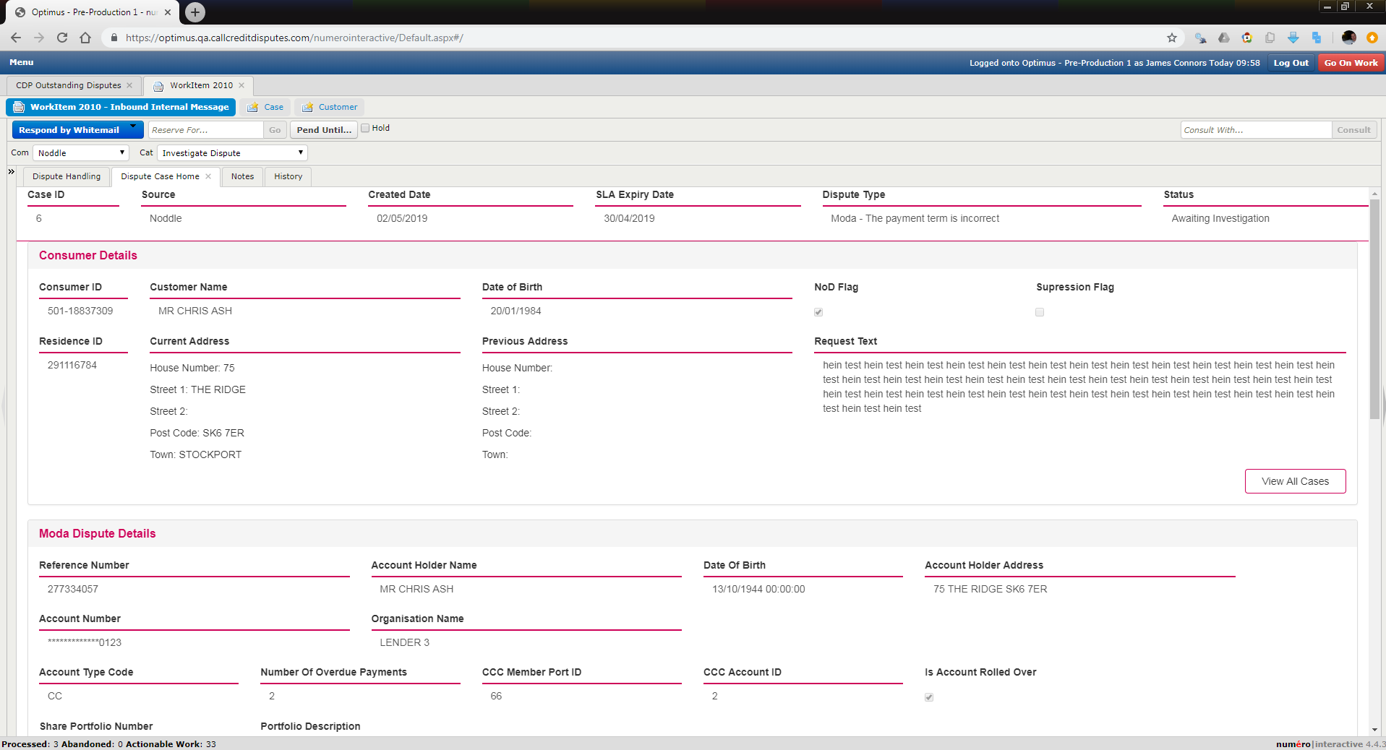

**IE**

Cleared history using Ctrl-Shift-Del and clicking clear data;

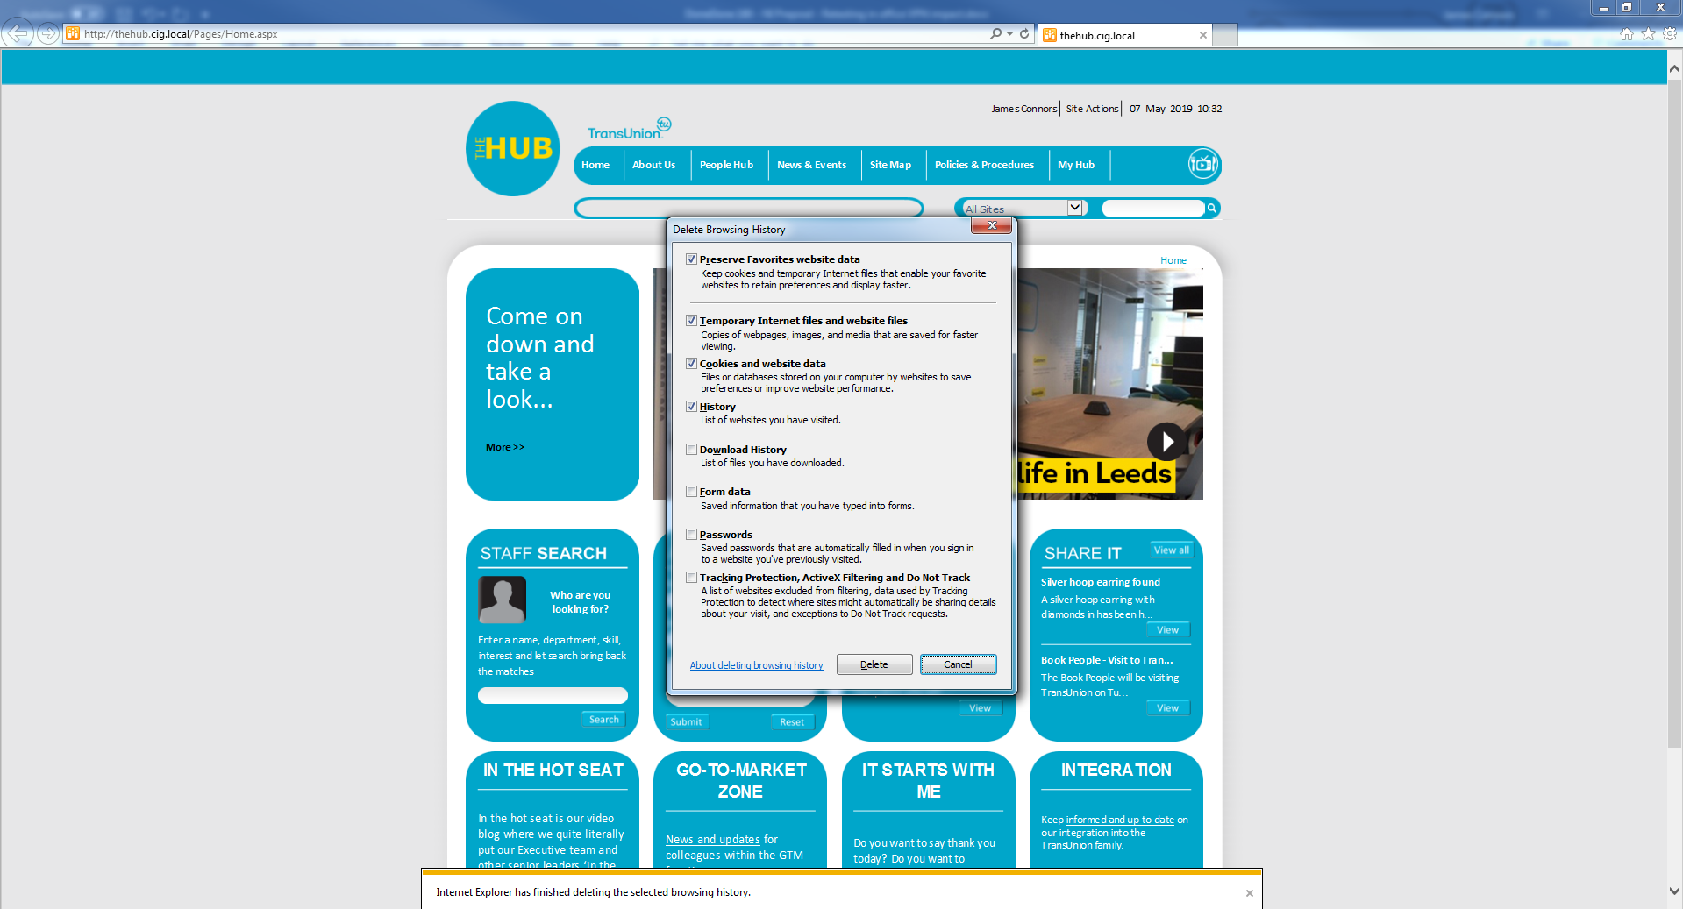

Navigated to <https://optimus.qa.callcreditdisputes.com/numerointeractive/>

Logged in fine and was able to open dispute without error;

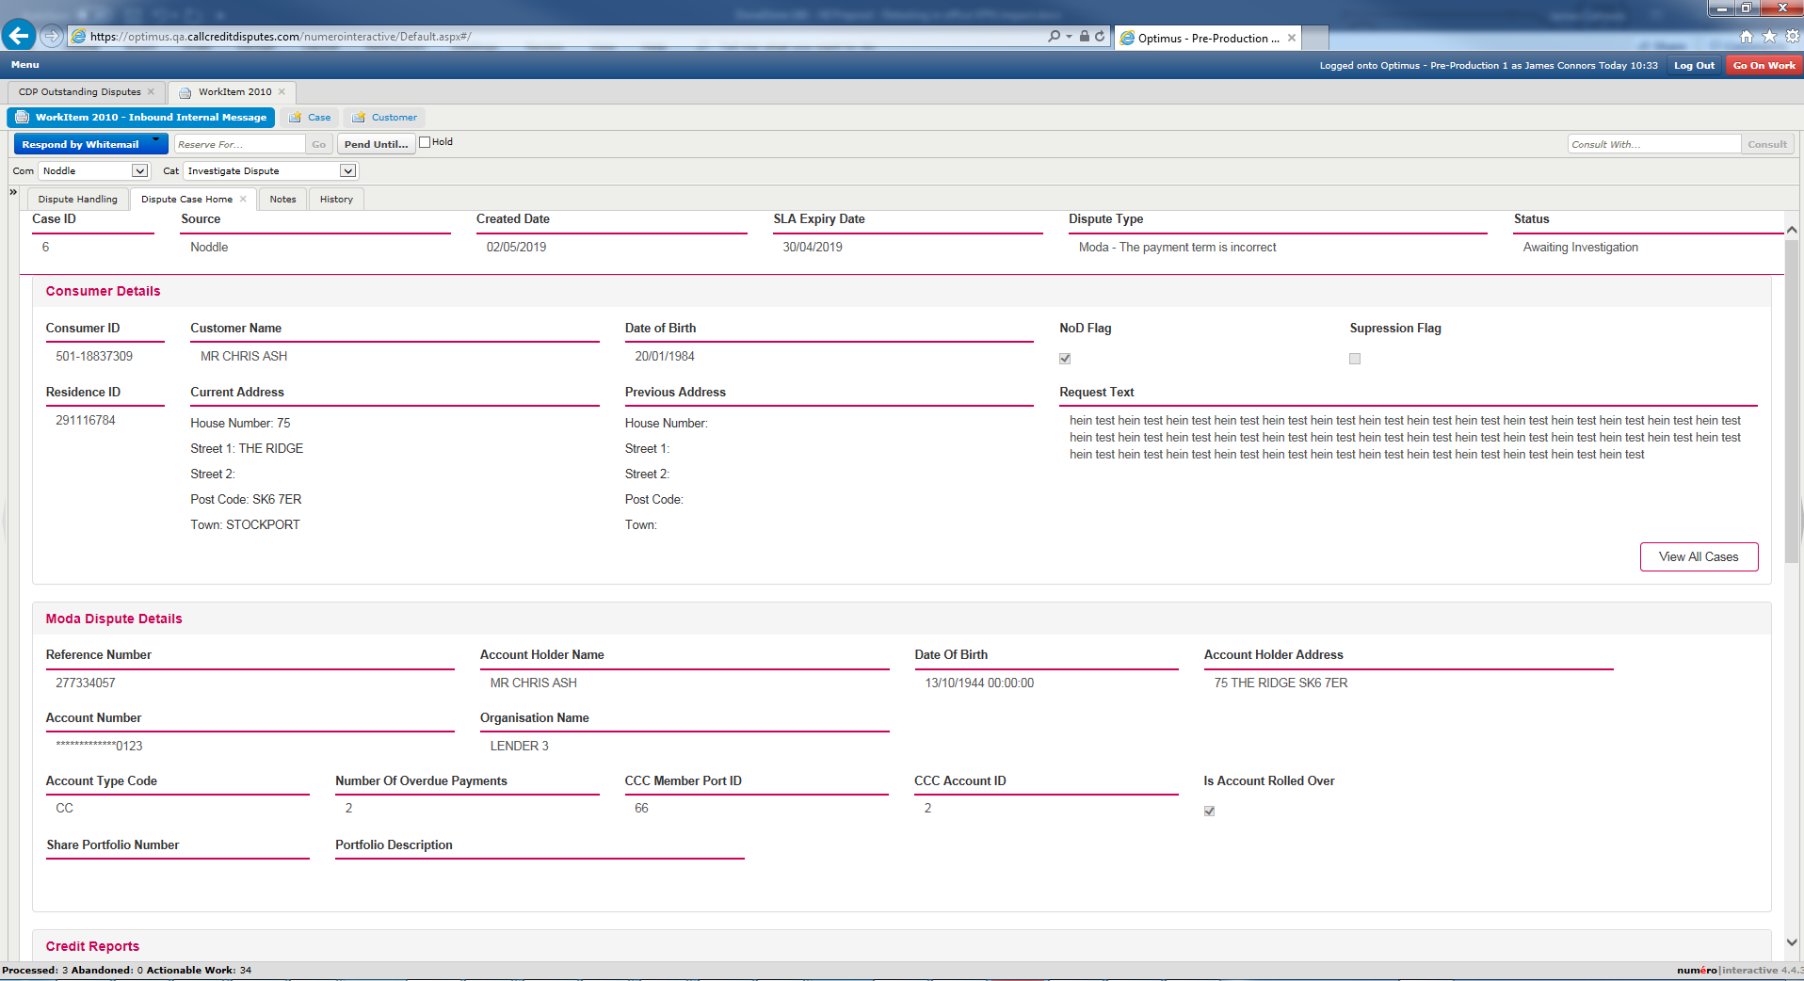

Left browsers and NI sessions open

Removed LAN cable, connected to James’ phone hotspot and connected to Cisco AnyConnect;

Checked if could carry on with open sessions and view disputes;

**Firefox**

Attepmted to close work item;

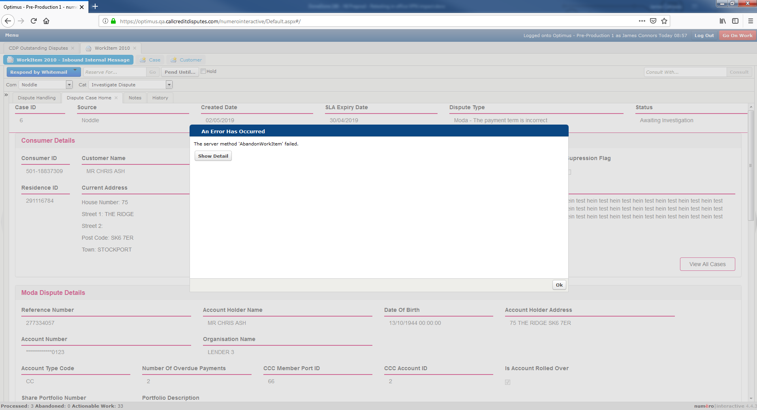

Clicked OK

Work item remained open.

Refreshed browser;

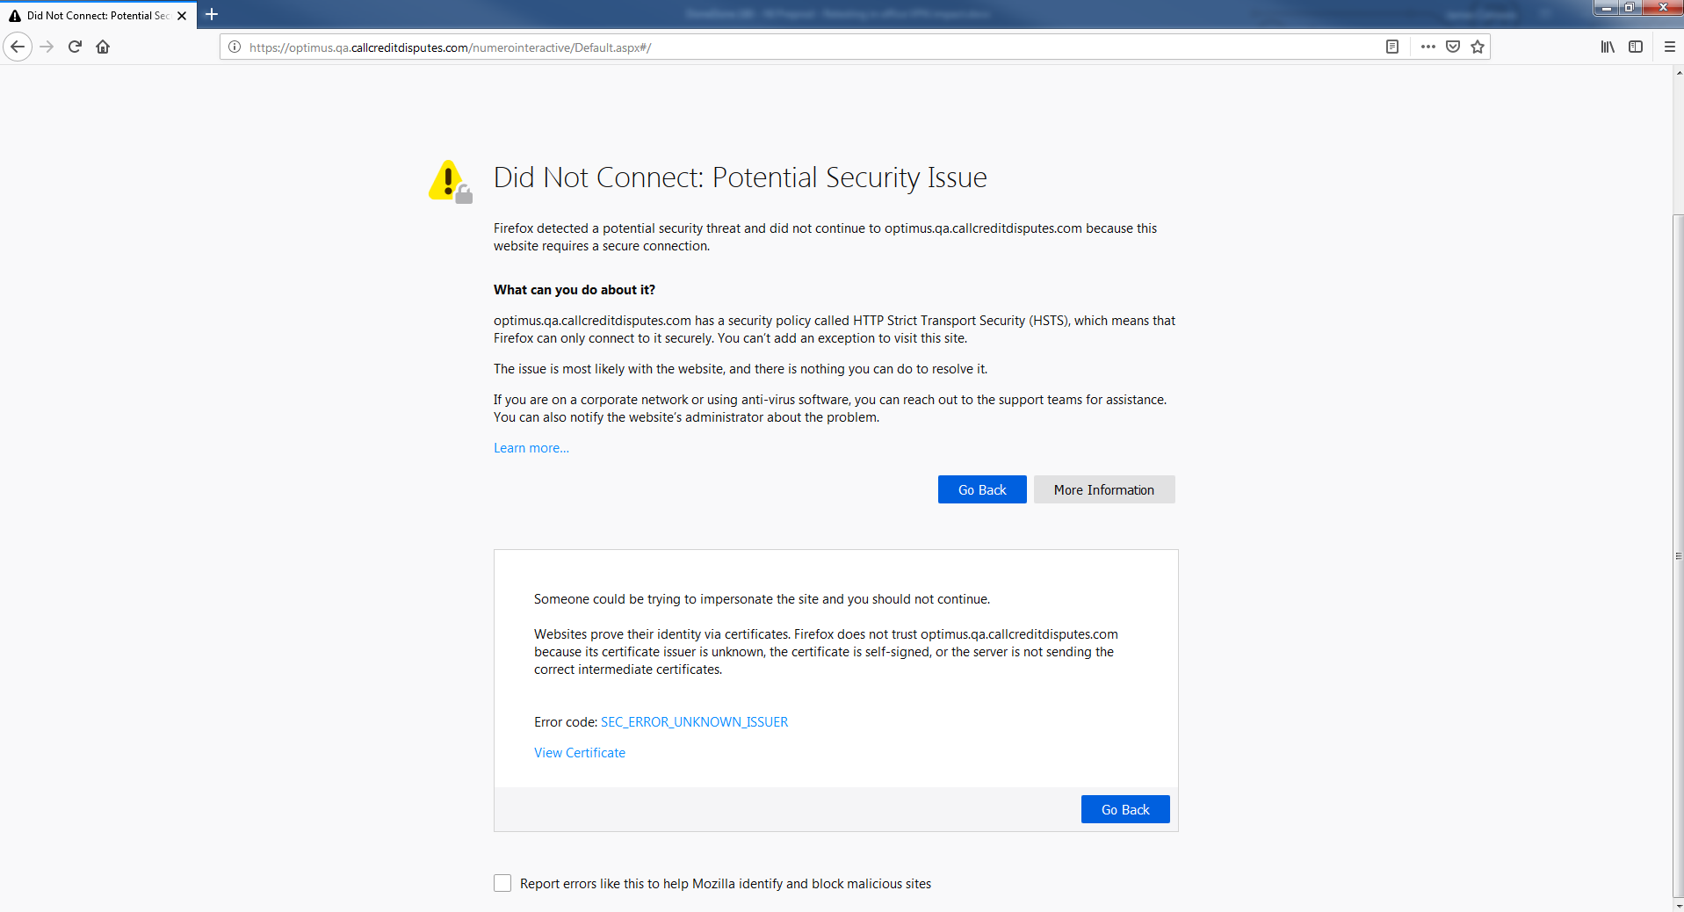

Closed browser, opened again and navigated to URL again

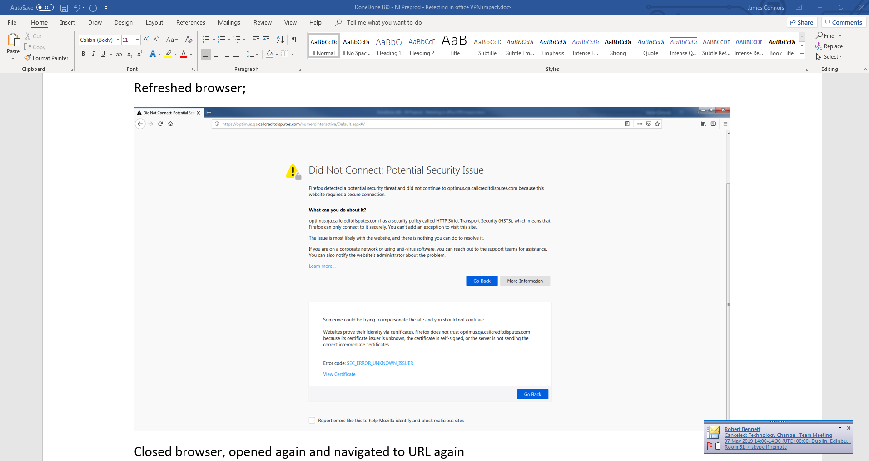

**Chrome**

Closed workitem;

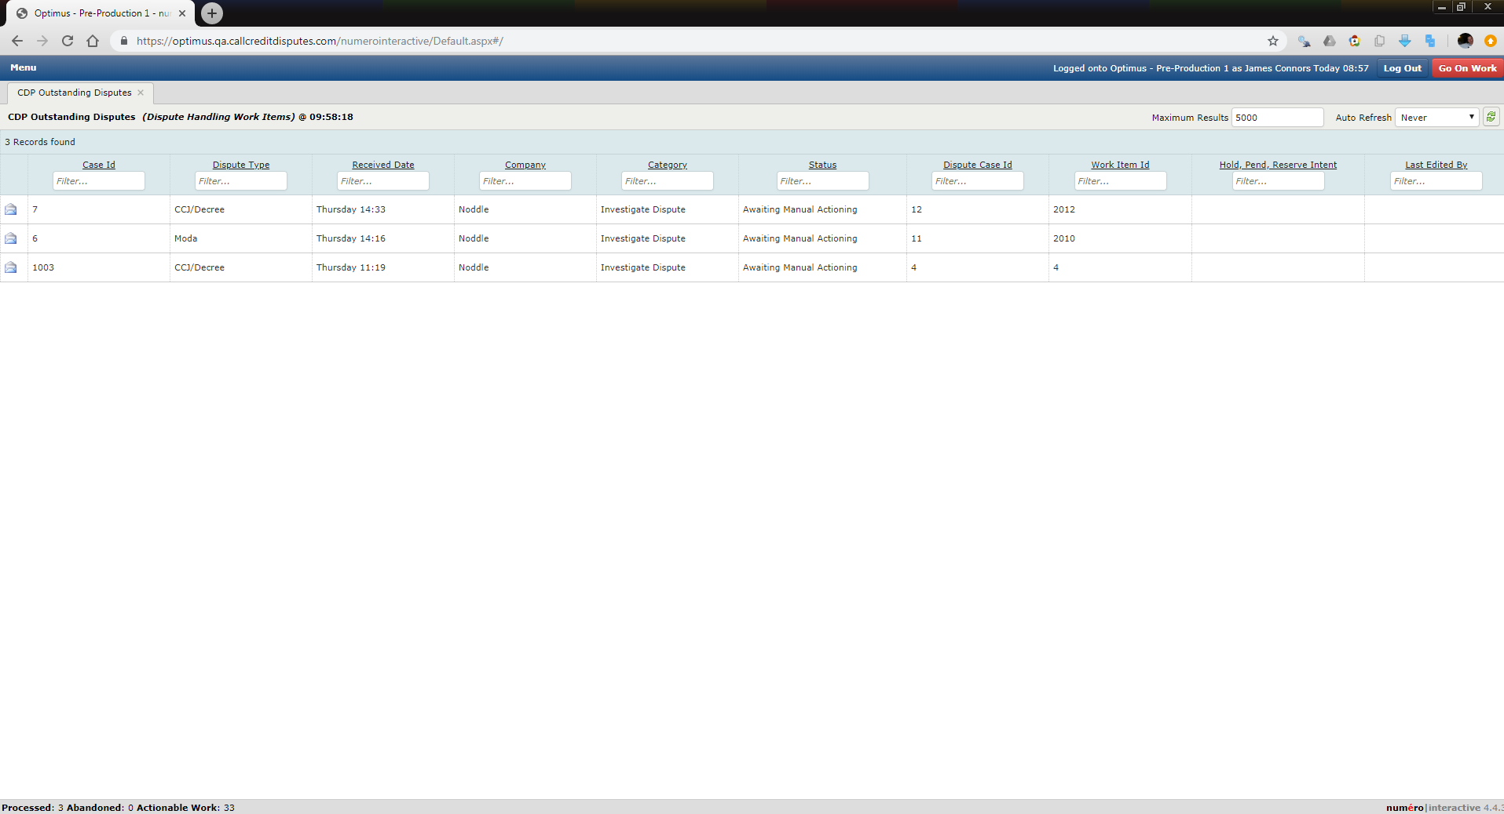

Clicked on dispute, it displayed ok without error;

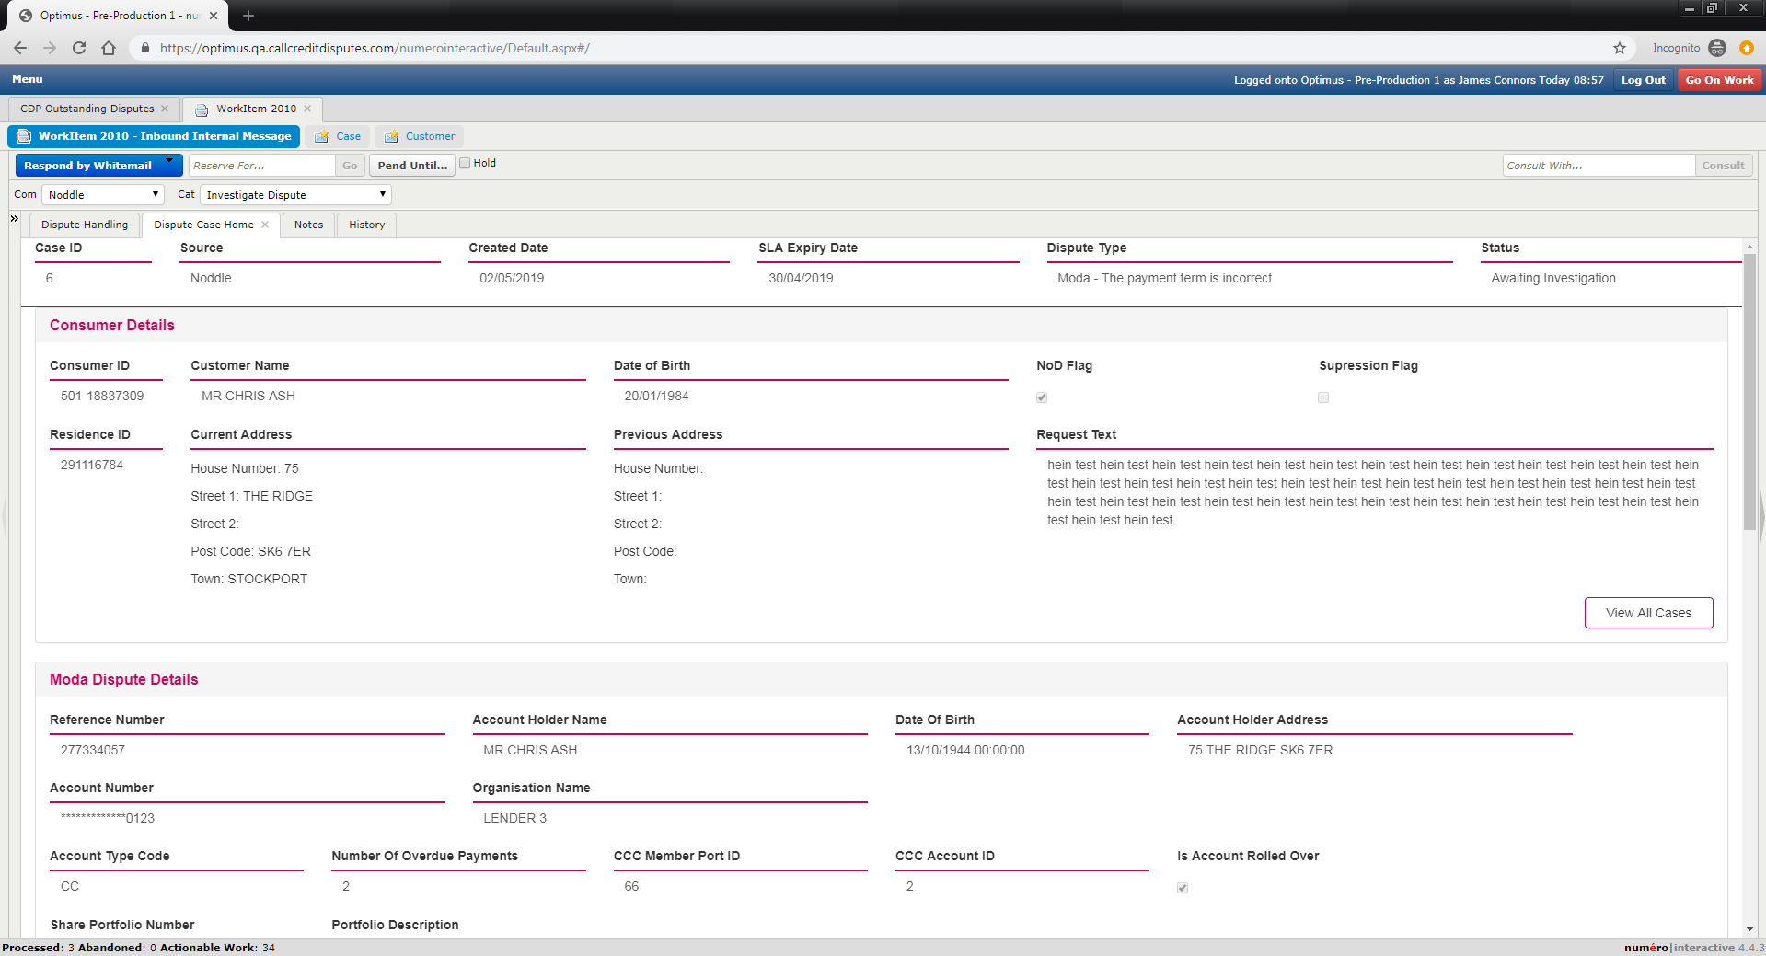

Closed work item, refreshed browser;

NI loaded fine and was able to open dispute;

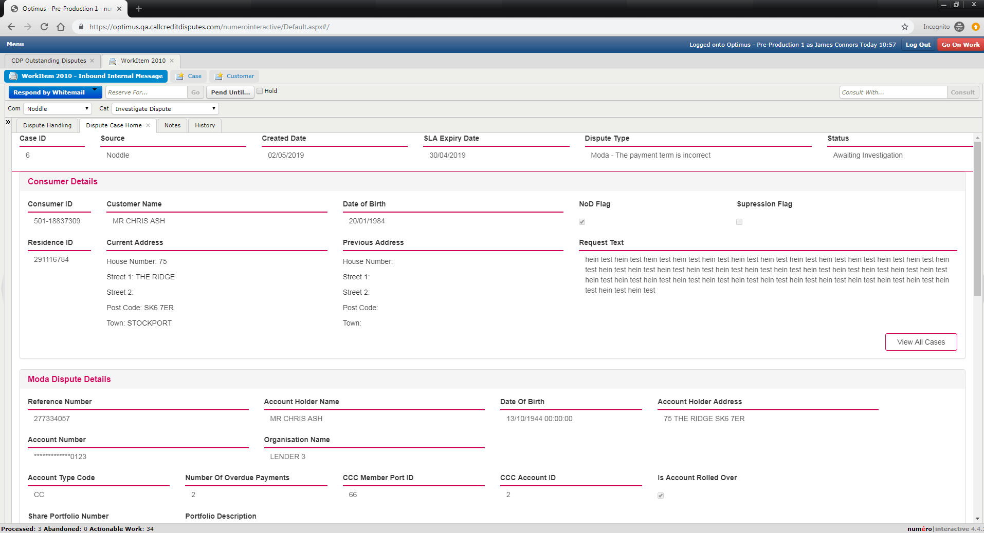

**IE**

Closed workitem;

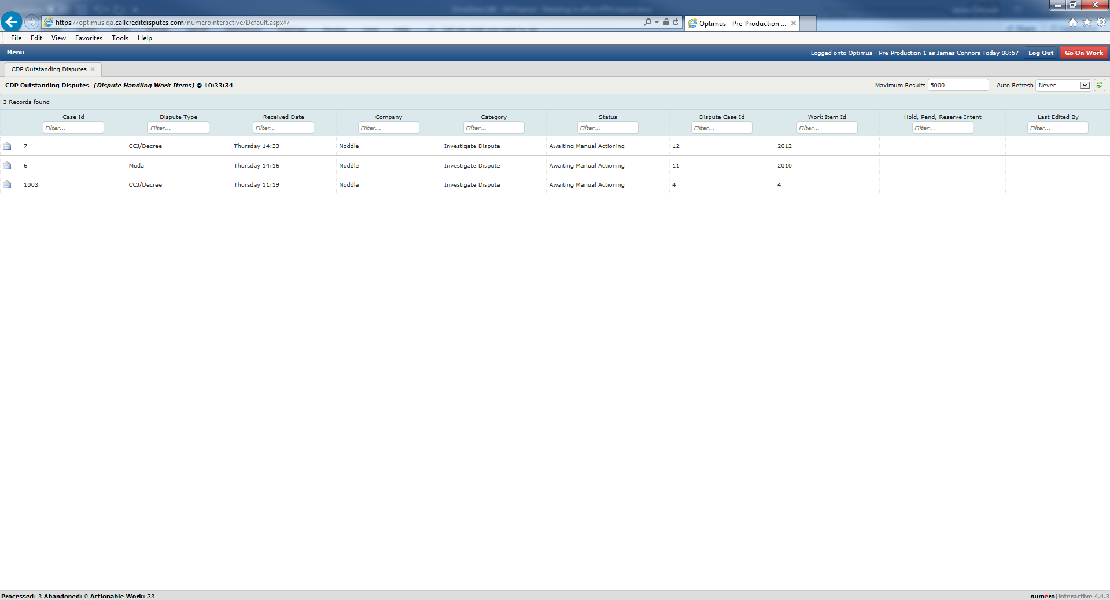

Clicked on dispute;

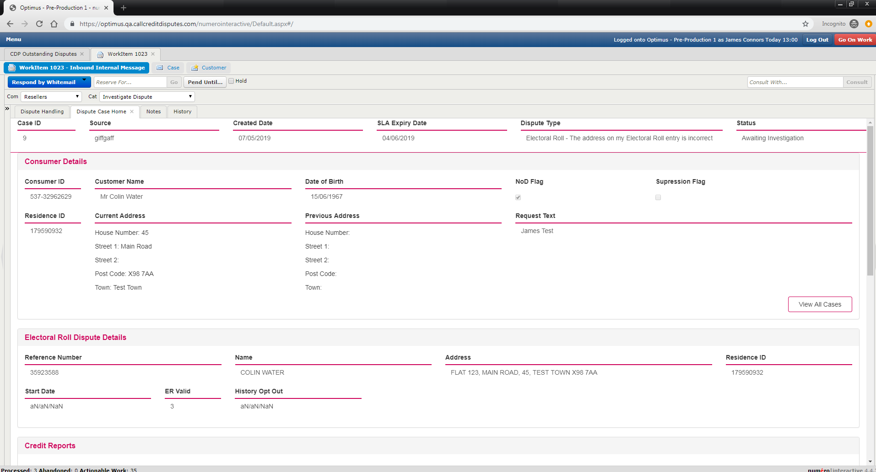

Refreshed browser;

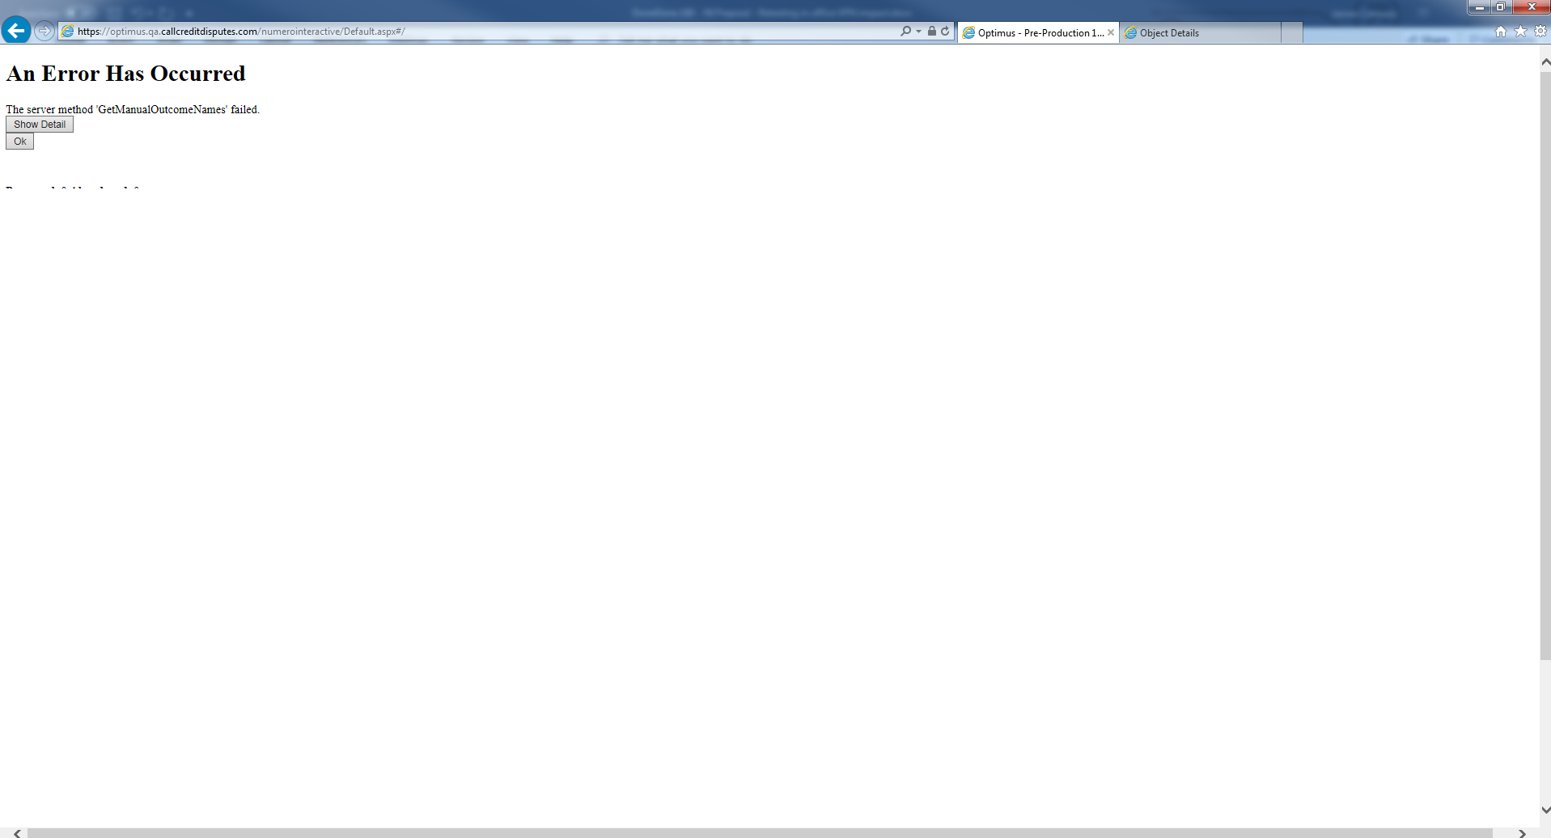

Refreshed again;

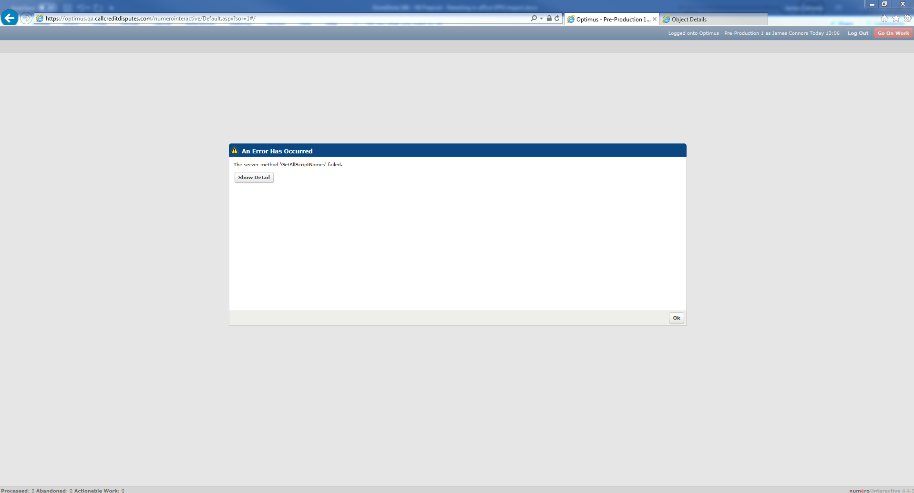

OK’d;

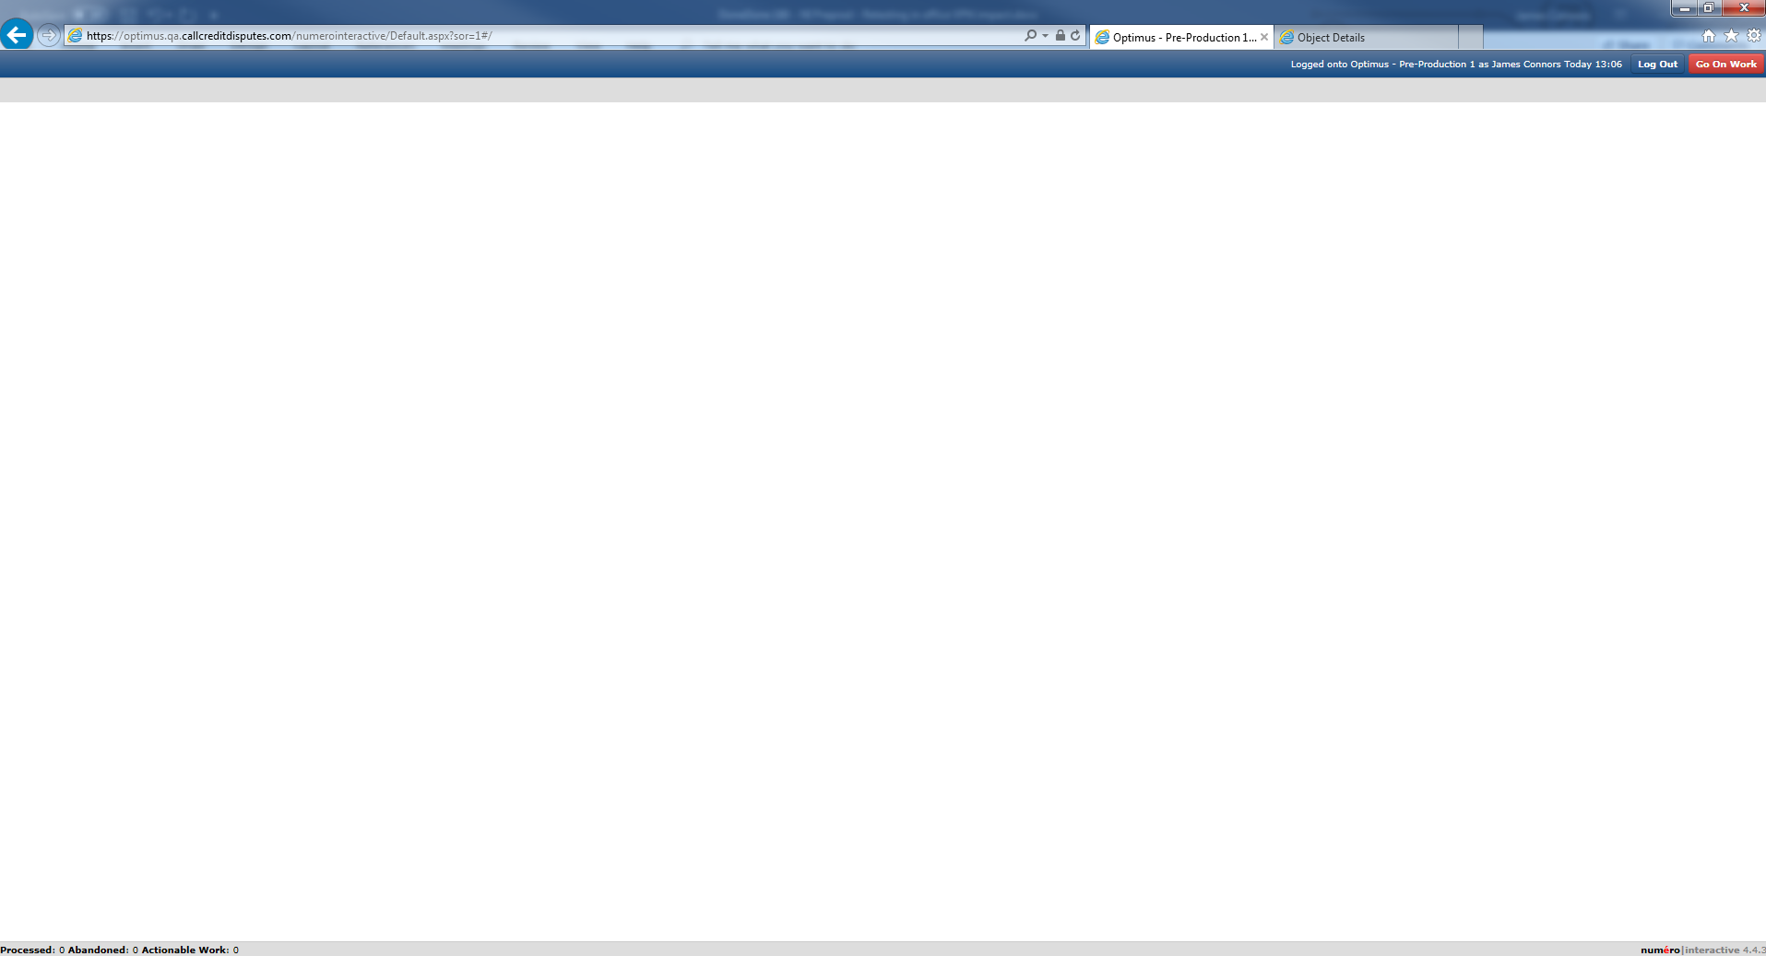

Refreshed again;

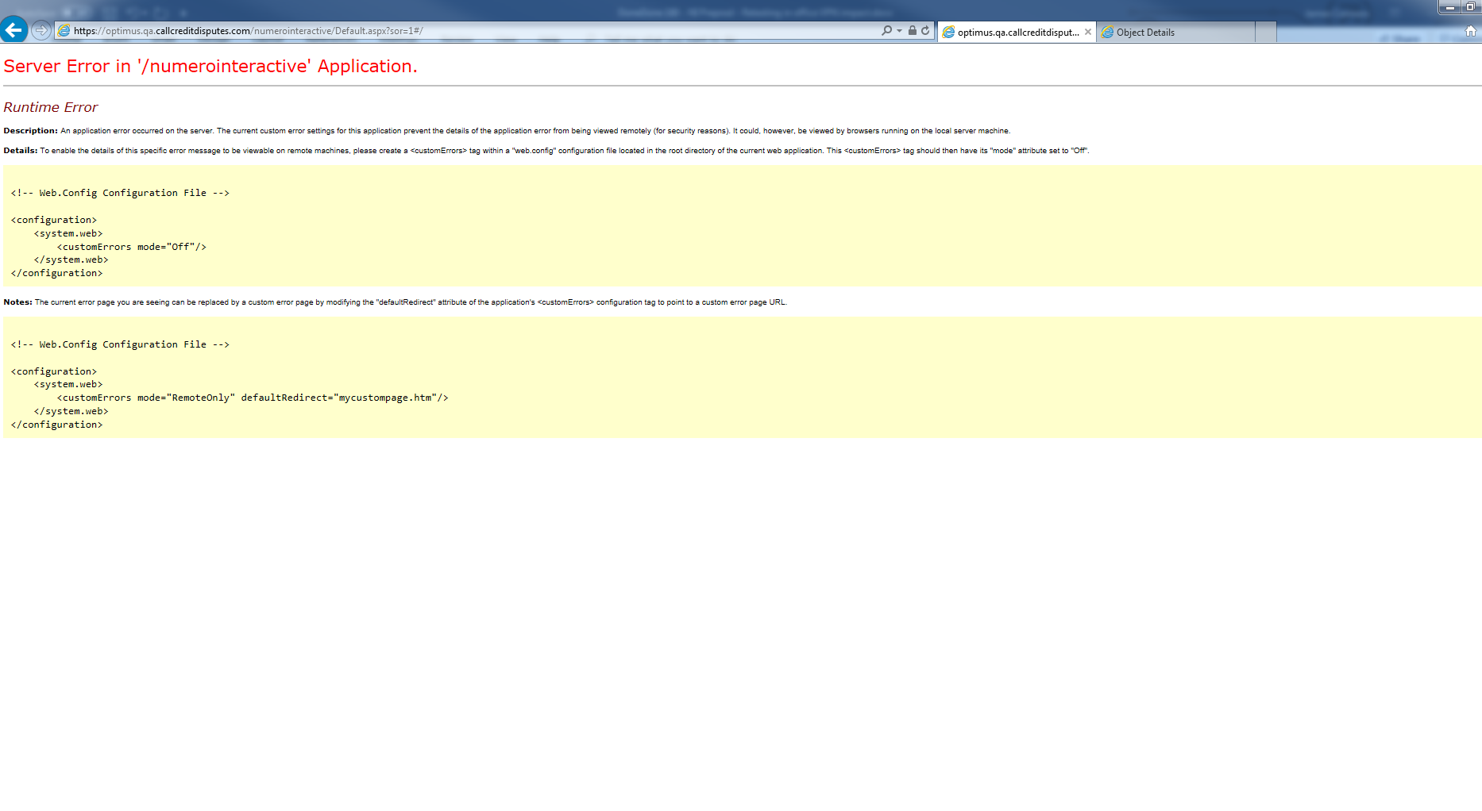

**Last Test to test clearing cache and cookies for all browsers whilst on VPN;**

**FIREFOX**

Cleared via ctrl-shift-del

Navigated to NI url;

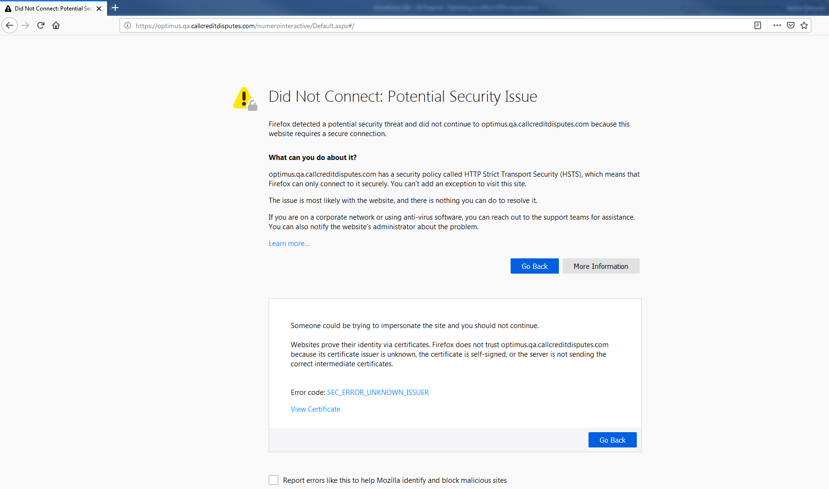

**Chrome**

Cleared cache using ctrl-shift-del

Closed browser, started incognito

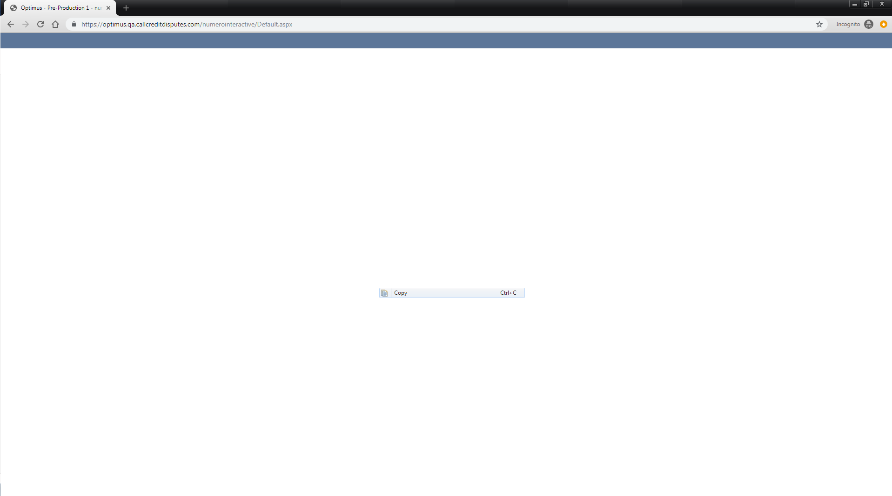

Cleared cookies and tried again;

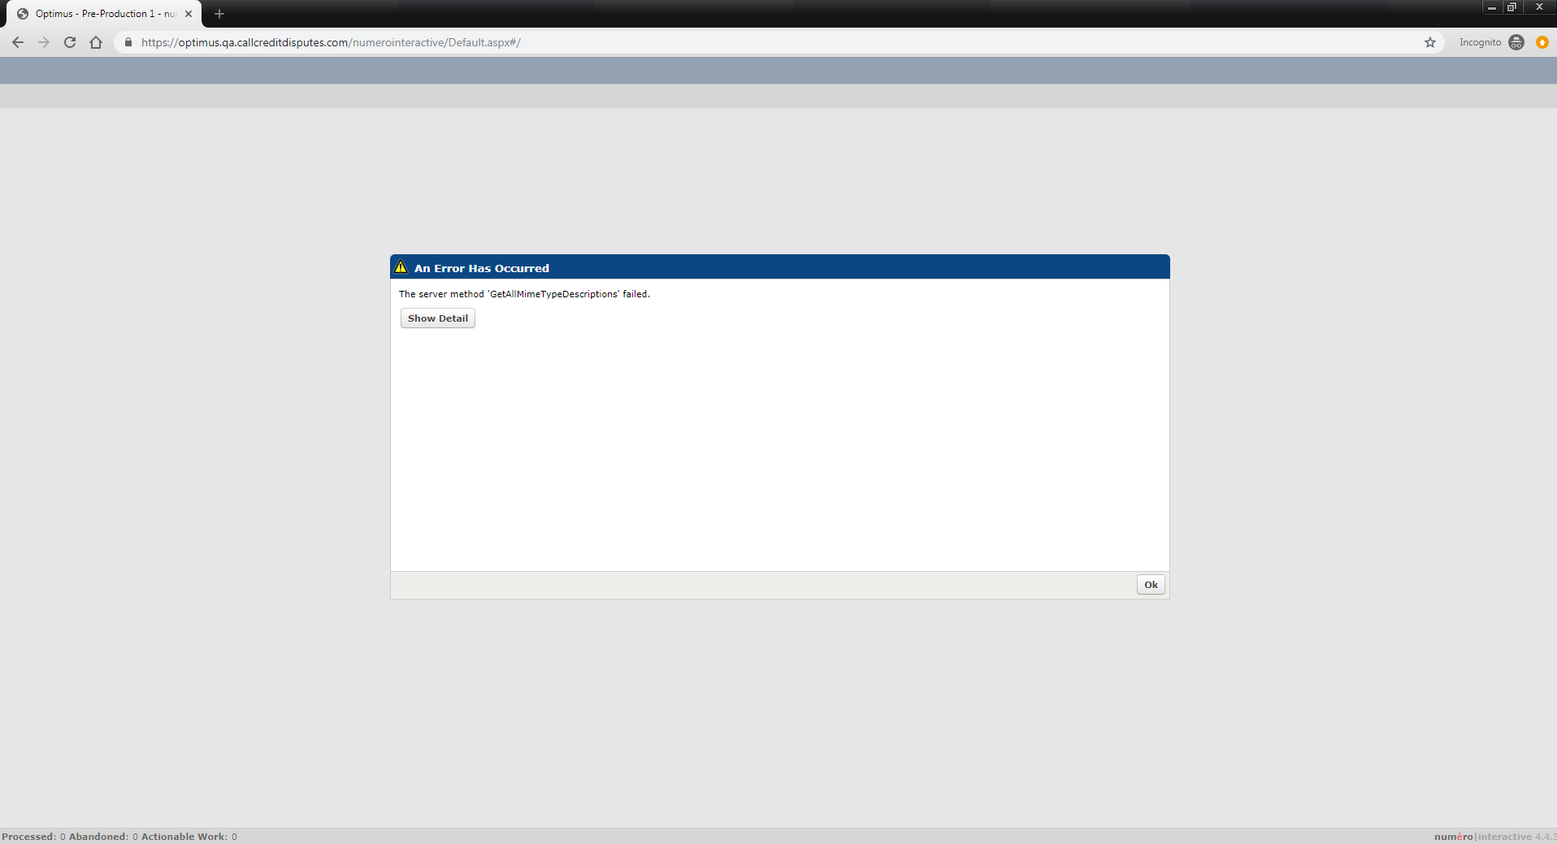

Clicked OK;

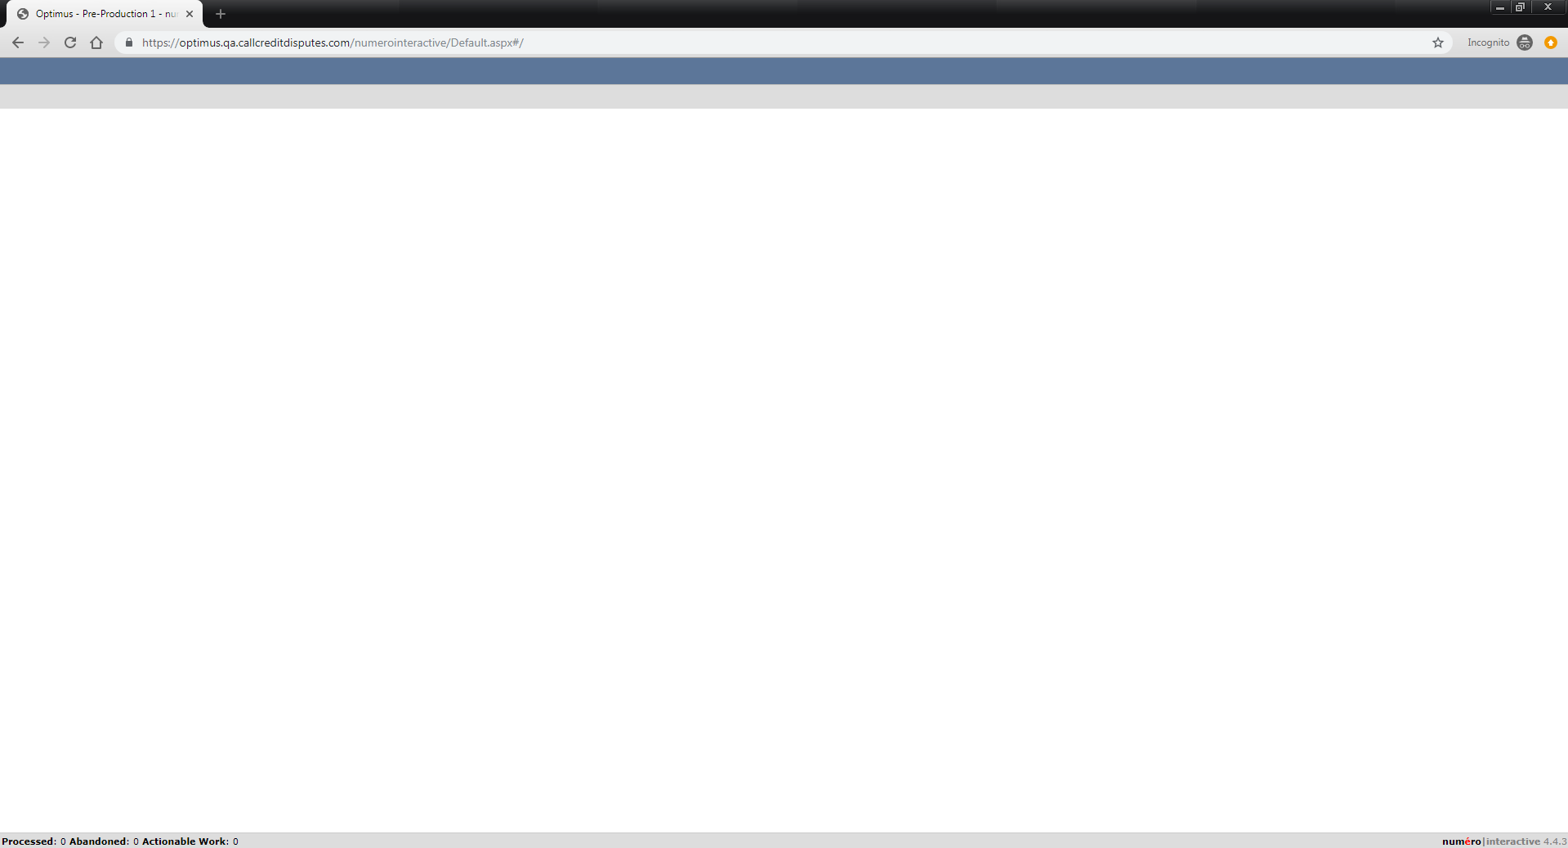

**IE**

Cleared cache using ctrl-shift-del

Closed browser

Reopened

Navigated to https://optimus.qa.callcreditdisputes.com/numerointeractive/

